**Aim:** Data Scrapping from a website and store it in the database.

**Objectives:**

**Tools Used:** Automation anywhere tools

**Concept:**

Action Used

1. Browser: Open The Browser package includes actions that facilitate the launching or closing of websites. The Open action is specifically employed to access the Flipkart website.

2. Browser: Close The Browser package encompasses actions that assist in the launching or closing of websites. The Close action is utilized to terminate the Flipkart website.

3. Record: Capture The Recorder package is designed to document a sequence of tasks within a process and subsequently automate them. The Capture action is employed to select any element from the web page and execute actions on the selected section.

4. Loop: Loop The Loop package enables the execution of specified actions a designated number of times. The Loop action is utilized to perform iterations by providing a selection of data.

5. If: Condition The If action assesses a condition and executes actions if the condition is true; otherwise, it bypasses them. This functionality aids in decision-making within a process.

6. Loop Break: Exit Loop The Loop Break action terminates a loop prematurely when a specific condition is satisfied, thereby preventing unnecessary iterations.

7. Log to File The Log to File package facilitates the creation of a log file containing data.

8. Number: Increment The Number package comprises actions that enable various numerical operations. The Increment action is utilized to increase the value of a number variable by one.

**Problem Statement:** Apply Web scrapping and extract data from the web page.

**Step 1:** Create a new bot by clicking on Home page of Automation Anywhere, Click on Create bot option. Give the bot name and click on “Create and edit”.

**Step 2**: To extract the data from a website, first we have to open the website by using Browser: Open action. Choose Browser. Give proper link to open.

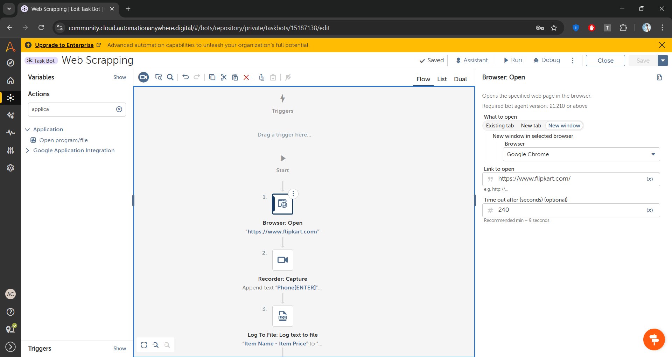

**Step 3:** Use Recorder: Capture action to capture the search bar of the website. Click on Browser. Select website window. Click on Recapture object. Select search bar. Select set text property. Enter the name of the product you want to search and enter.

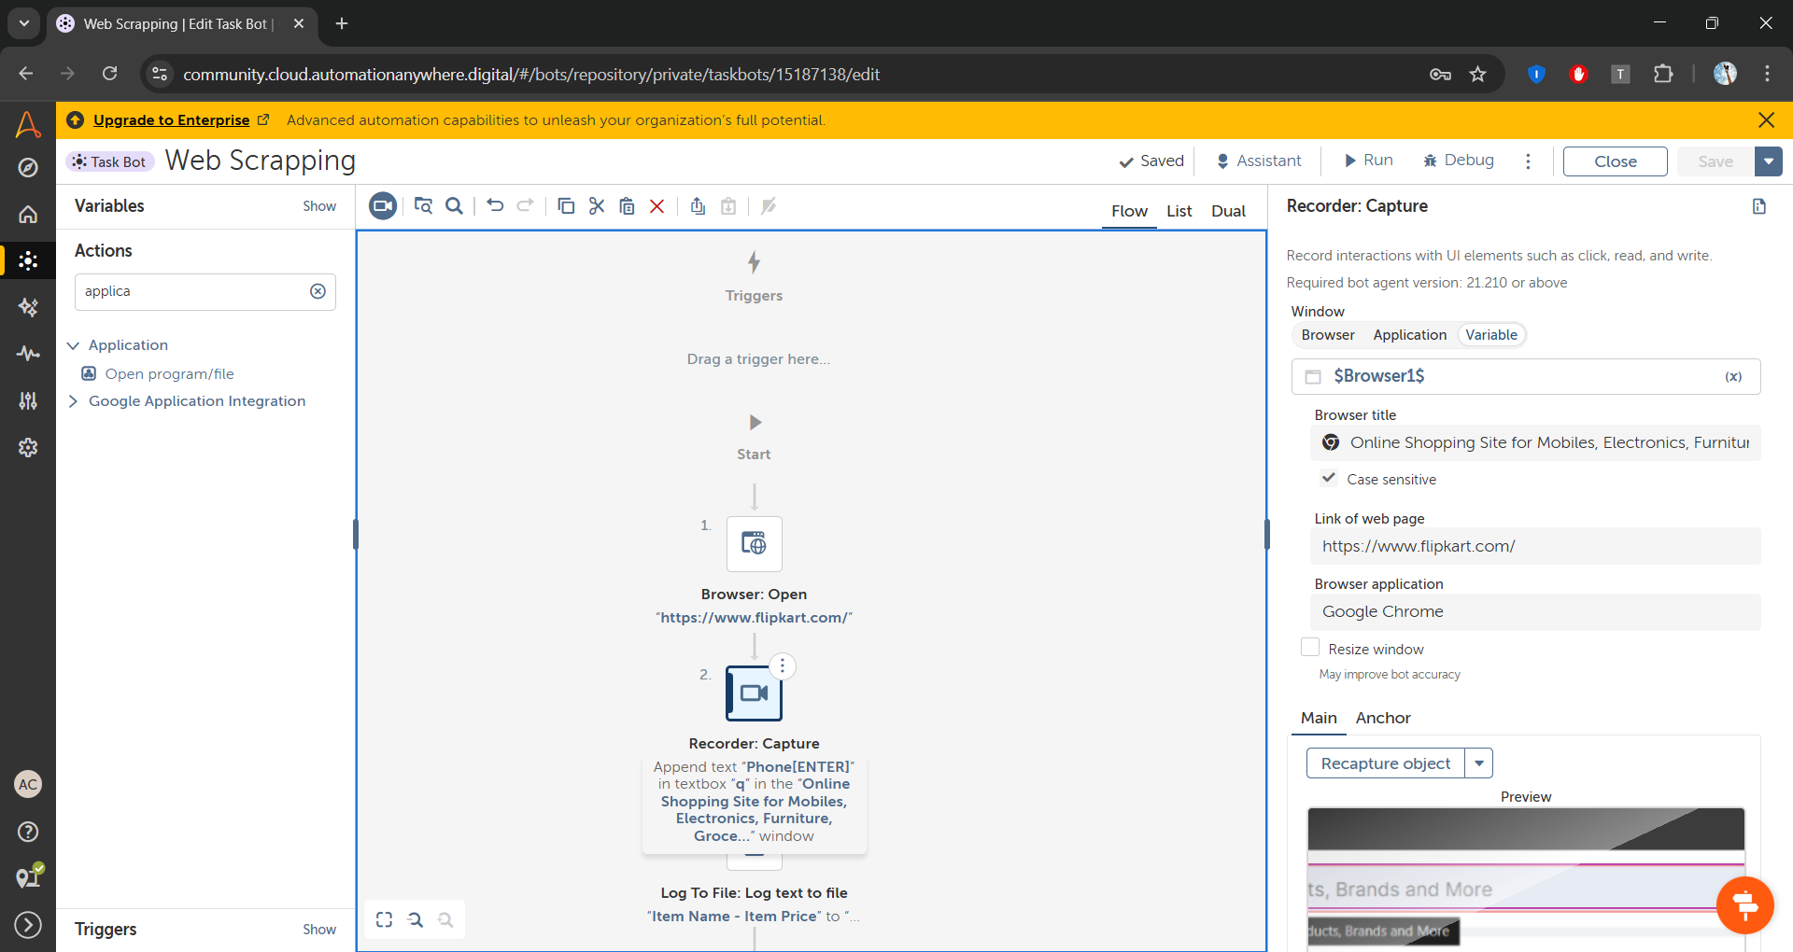

**Step 4:** Add Log to text file action and specifies the path of the file in which data should added and click save.

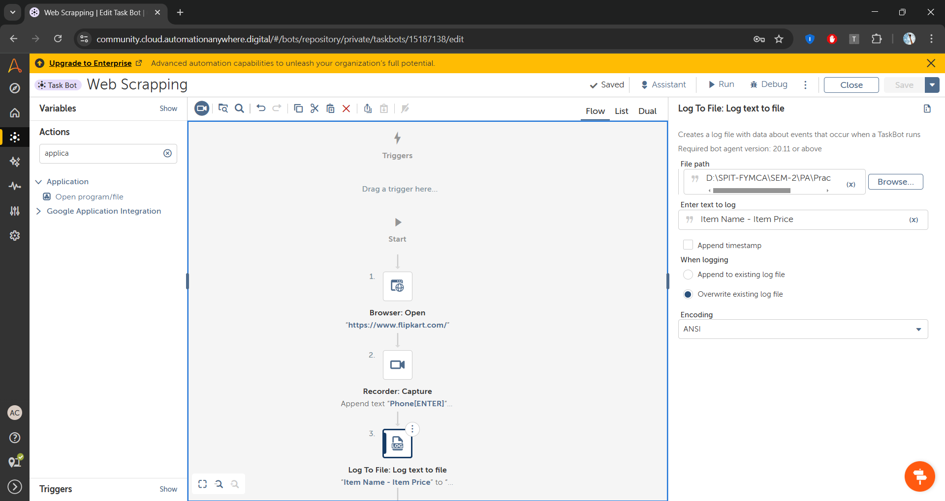

**Step 5:**  Add loop action and in while tab capture product name area and click save

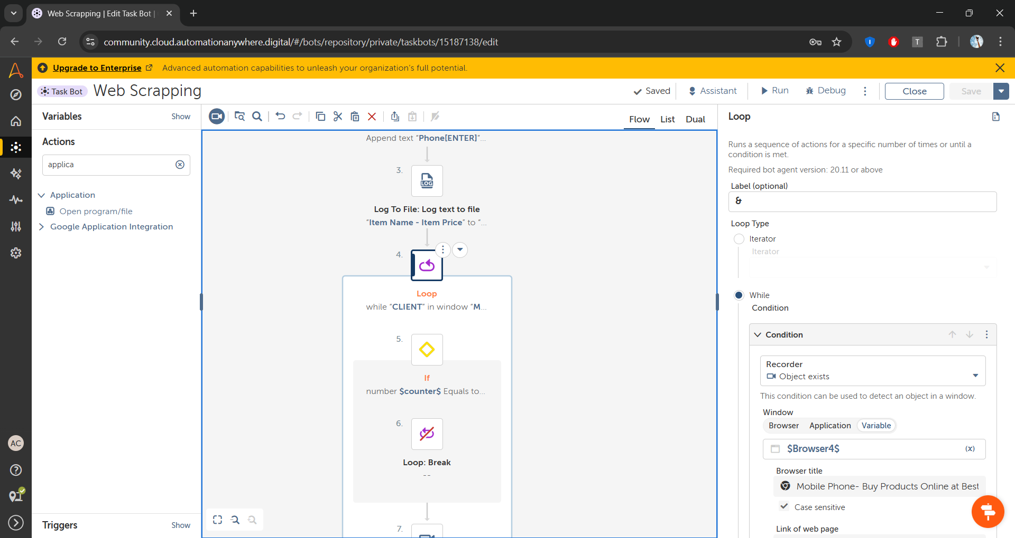

**Step 6:** Add if condition and create a variable counter1 and add condition greater than 15

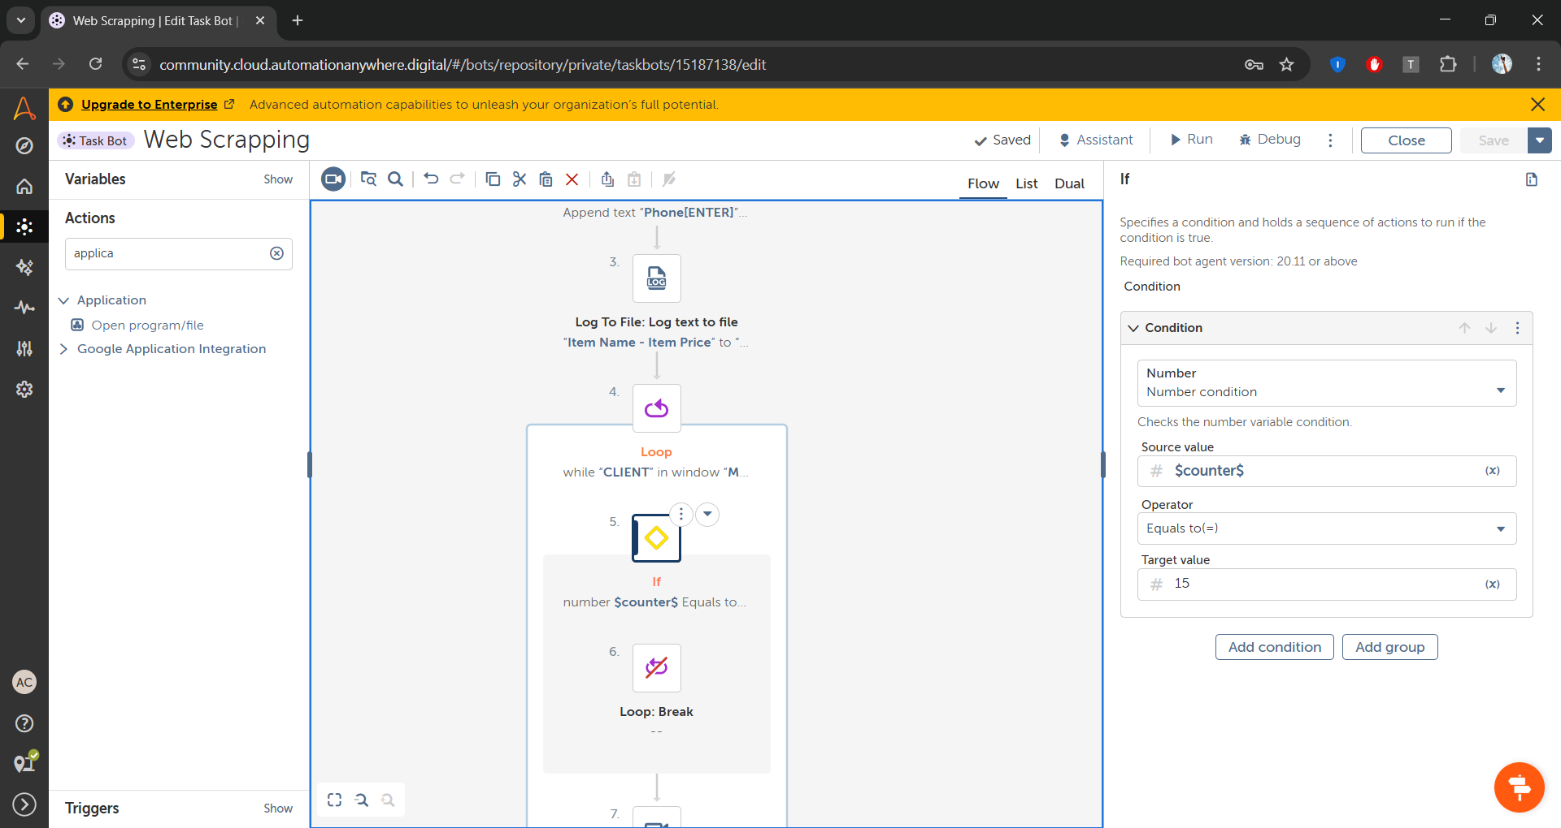

**Step 7:** Add loop break inside the if condition

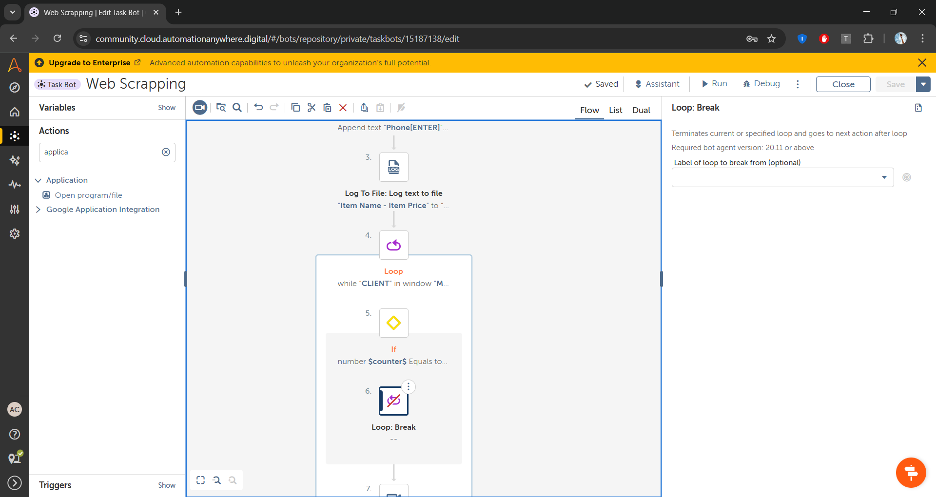

**Step 8:** Add recorder capture action to capture phone name(item_name). In Get Property Action and use HTMLInner Text property. Copy the domxpath somewhere

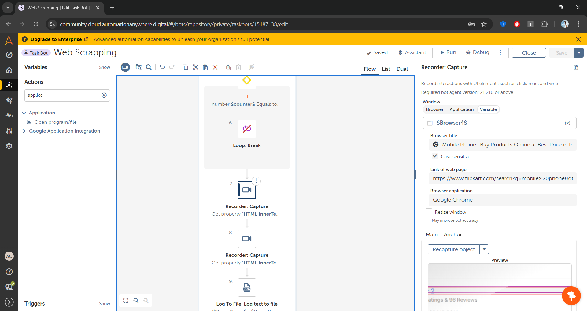

**Step 8:** Add recorder capture action to capture phone price(item_price). In Get Property Action and use HTMLInner Text property. Copy the domxpath somewhere

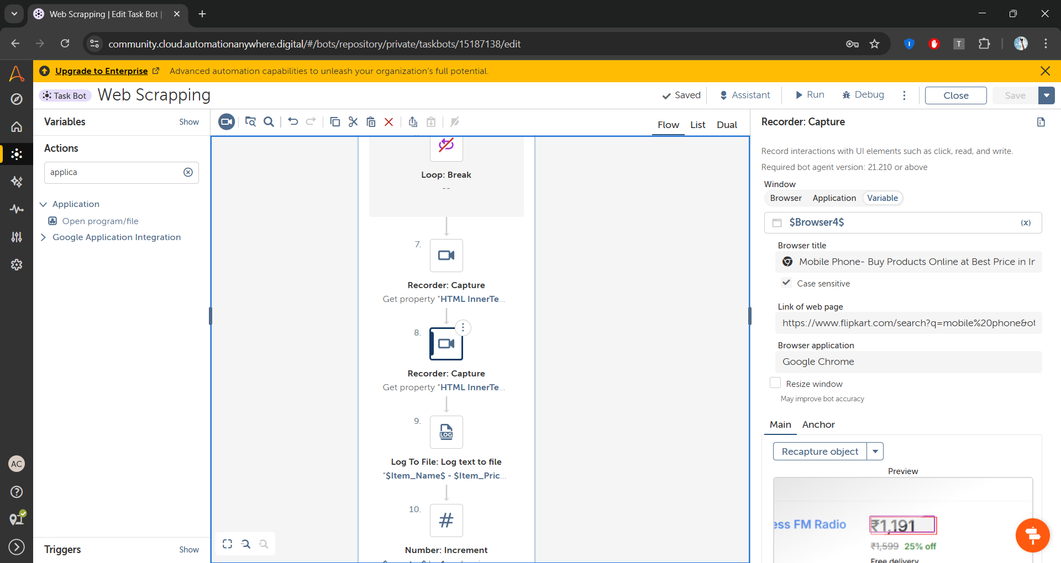

**Step 9:** Add log to text file and specifies the file in which data should add and select append to existing file option.

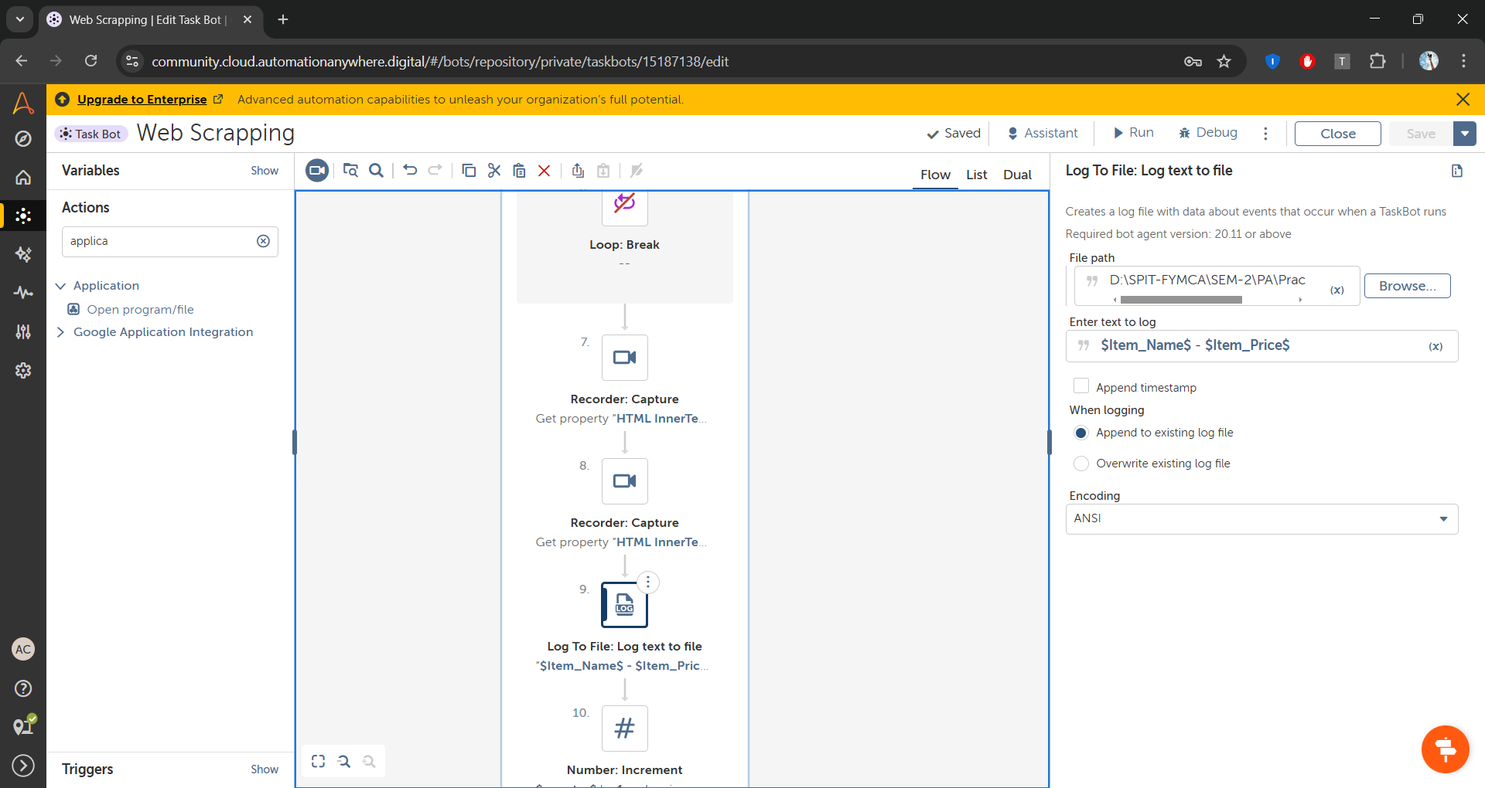

**Step 10:** Add Number:Increment to increment the counter1 variable by 1

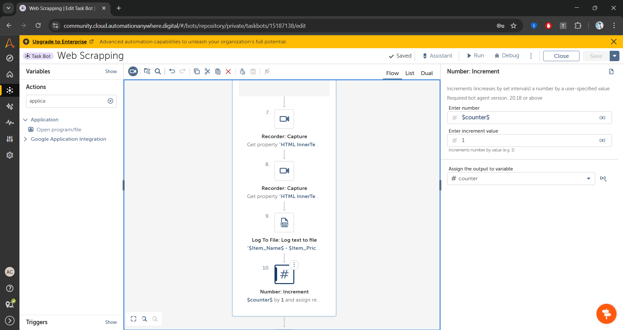

**Step 11:** Add window close and add the link of the window to close

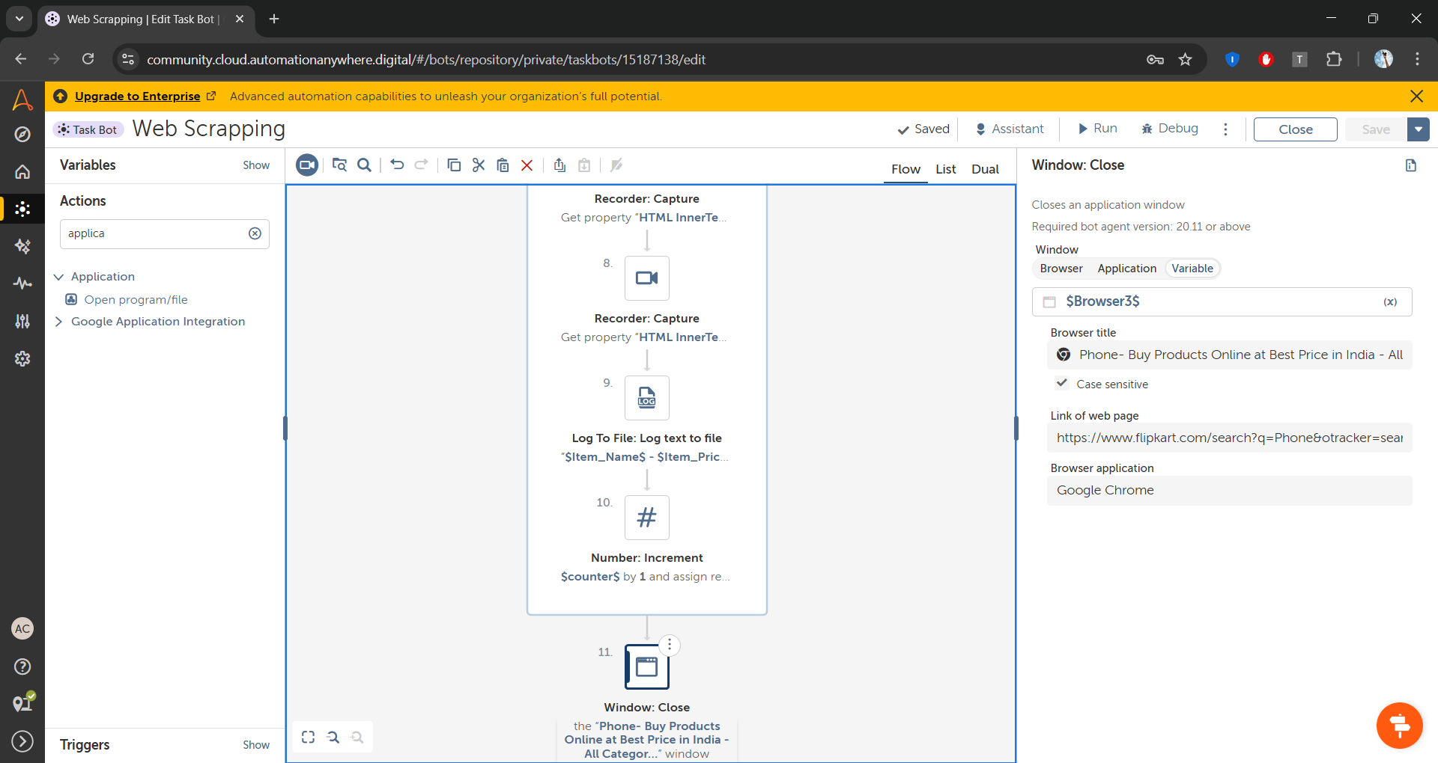

**Step 12:** Add Application:Open Program to open the file in which data stored.

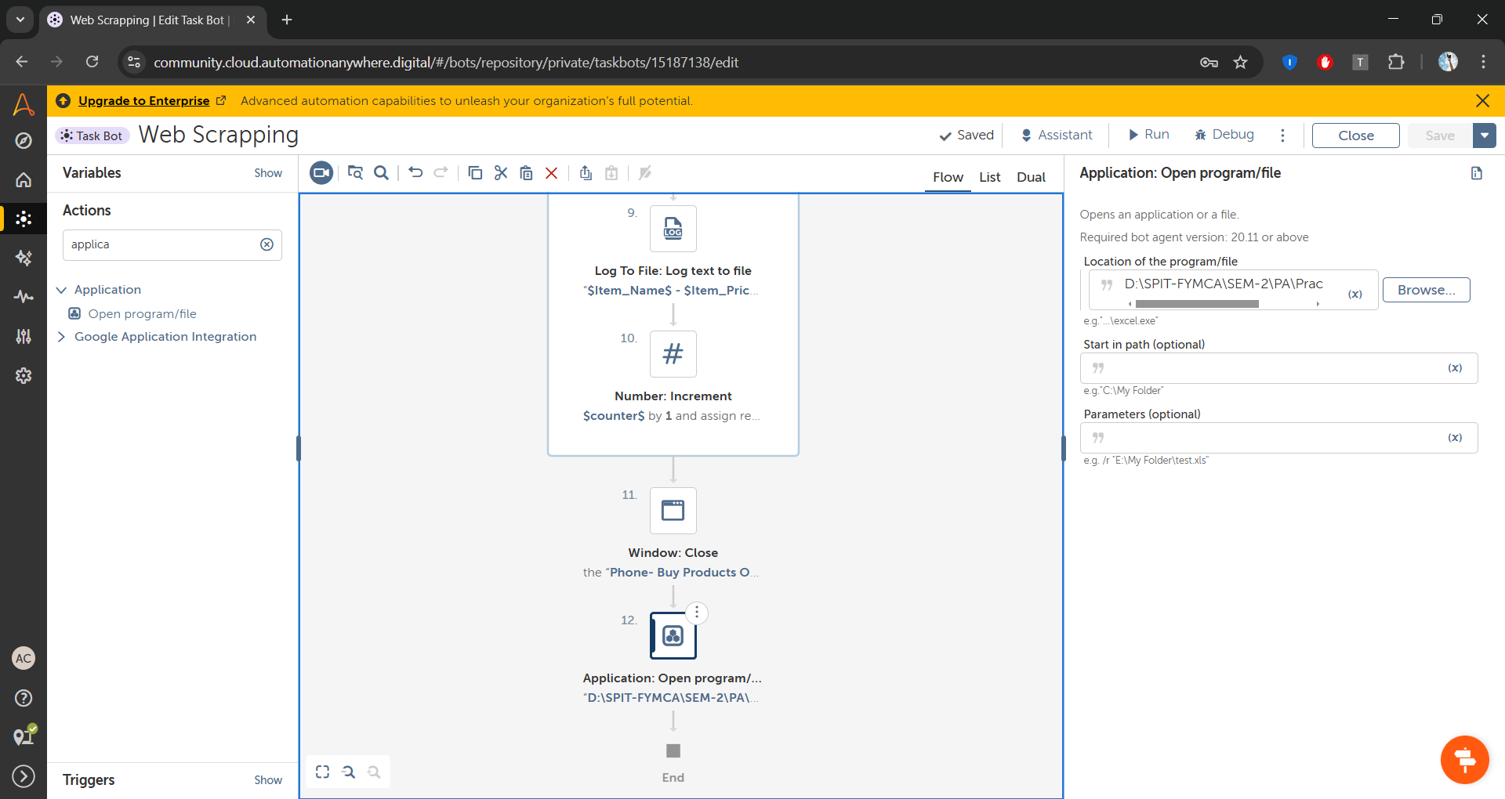

**Step 13:** Now run the bot

**Output:**

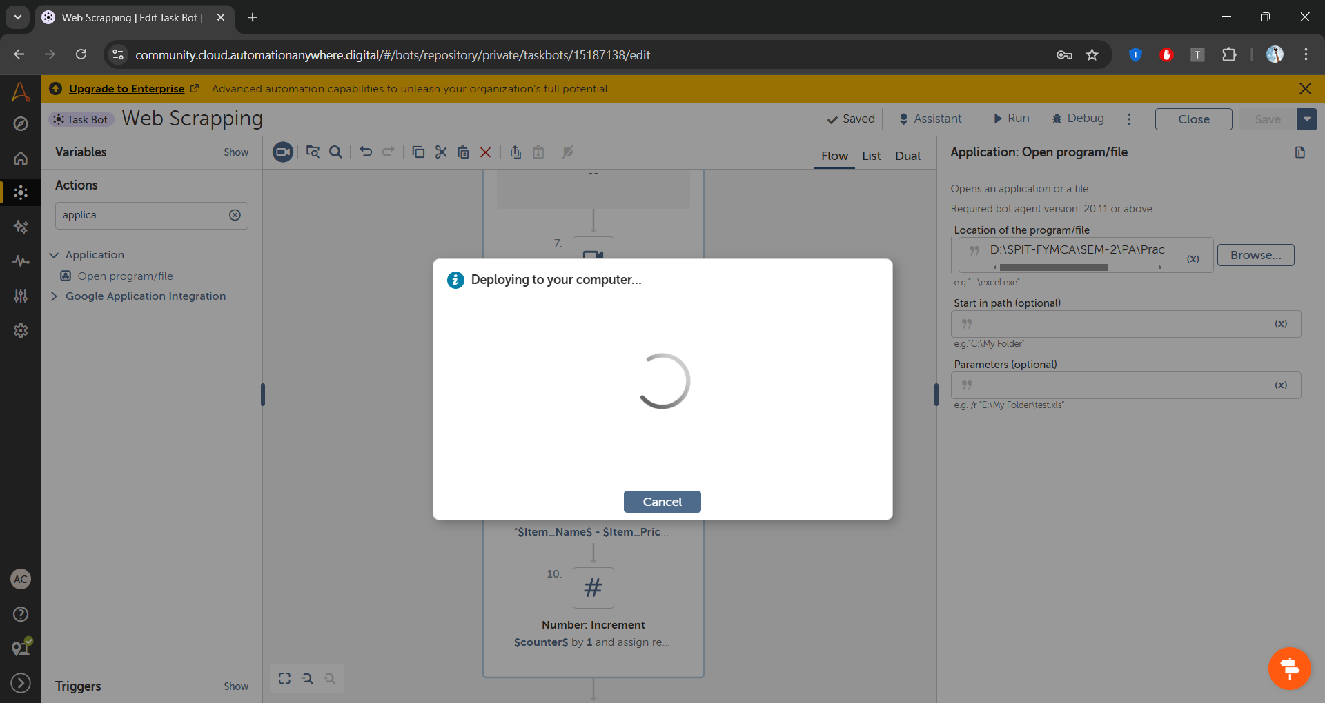

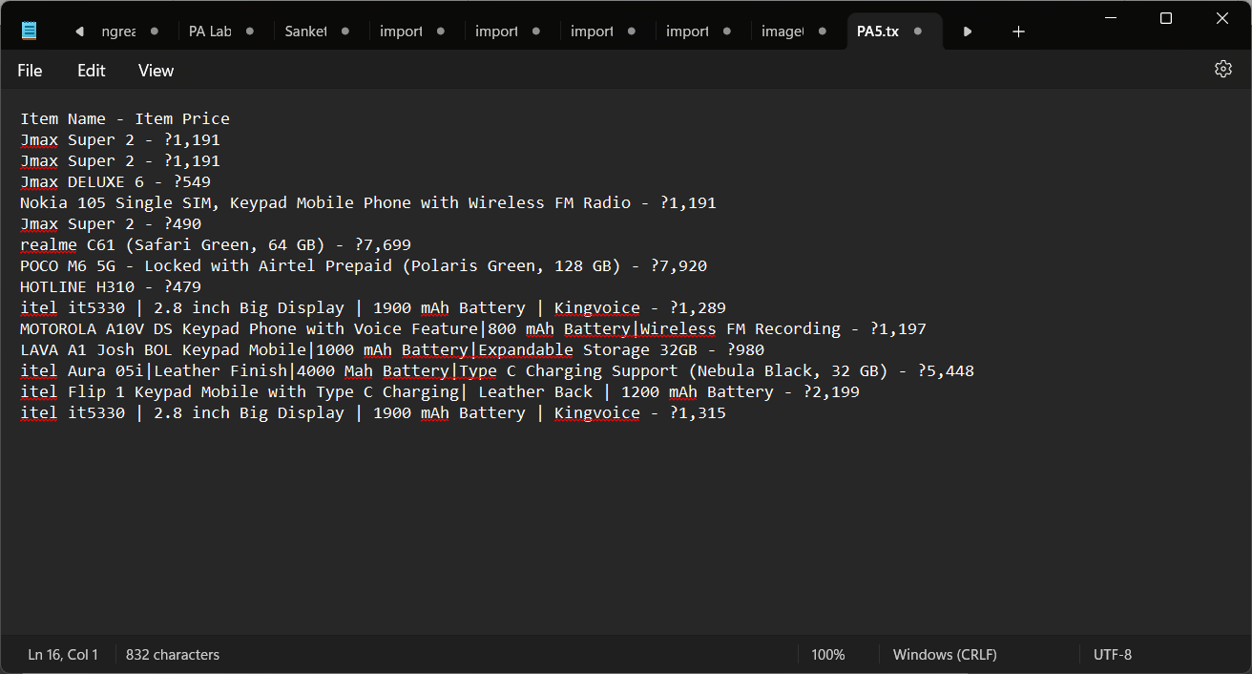

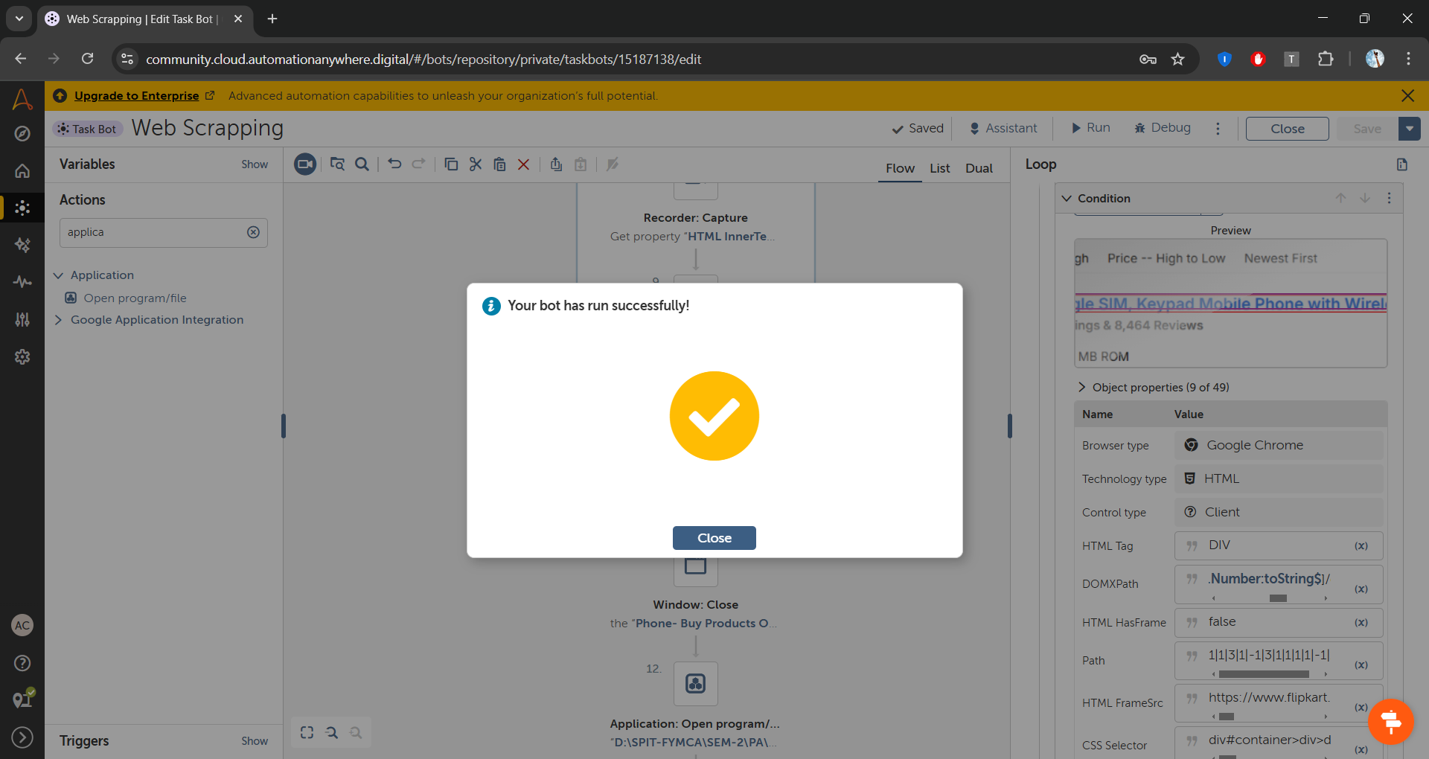

**Observation:** I learned to automate web tasks in this practical. I can now open and close a browser, capture web elements, and log data. Using loops and conditional statements makes it easier to manage repetitive tasks. The Loop Break action allows me to stop iterations when necessary. Also, performing number operations like increasing values improves the automation process.